|  |  |  |  |
| --- | --- | --- | --- |
|  | | | |
| **Expt. No:** | | **2** | **Diode Clipper Circuits** |
|  | | |
| **Date:** |  | |
|  | | | |



**Aim:**  To implement various diode clamper circuits and verify its performance using Multi-Sim software

**SOFTWARE TOOLS / OTHER REQUIREMENTS:**

1. Multisim Simulator/Circuit Simulator

# Theory:

# A clamper is a network constructed of a diode, a resistor, and a capacitor that shifts a waveform to a different dc level without changing the appearance of the applied signal.

# Additional shifts can also be obtained by introducing a dc supply to the basic structure. The resistor and capacitor of the network must be chosen such that the time constant determined by τ=RC is sufficiently large to ensure that the voltage across the capacitor does not discharge significantly during the interval the diode is not conducting. Throughout the analysis we assume that for all practical purposes the capacitor fully charges or discharges in five-time constants. The simplest of clamper networks is shown in figure below.

# Clamping networks have a capacitor connected directly from input to output with a resistive element in parallel with the output signal. The diode is also in parallel with the output signal but may or may not have a series dc supply as an added element.

**Six type of clamper circuits are as follows:**

**1. Positive clamper**

**2. Positive clamper with positive Vt**

**3. Positive clamper with negative Vt**

**4. Negative clamper**

**5 Negative clamper with positive Vt**

**6 Negative clamper with negative VT**

**circuit diagrams**

**1. positive clamper ciircuit:**

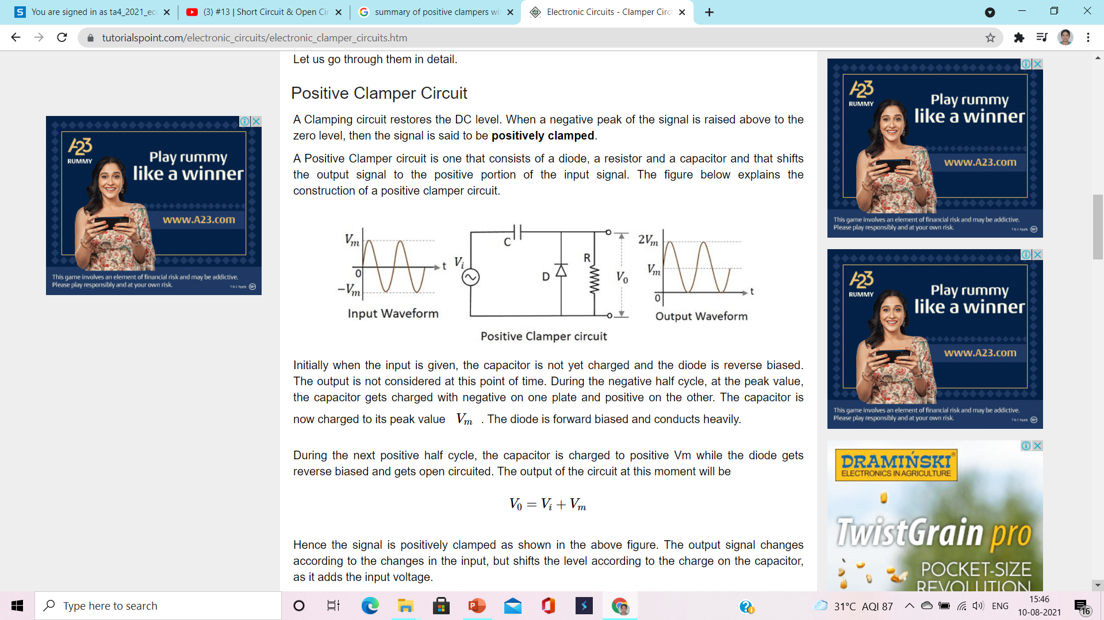

**2. Positive clamper with positive Vt**

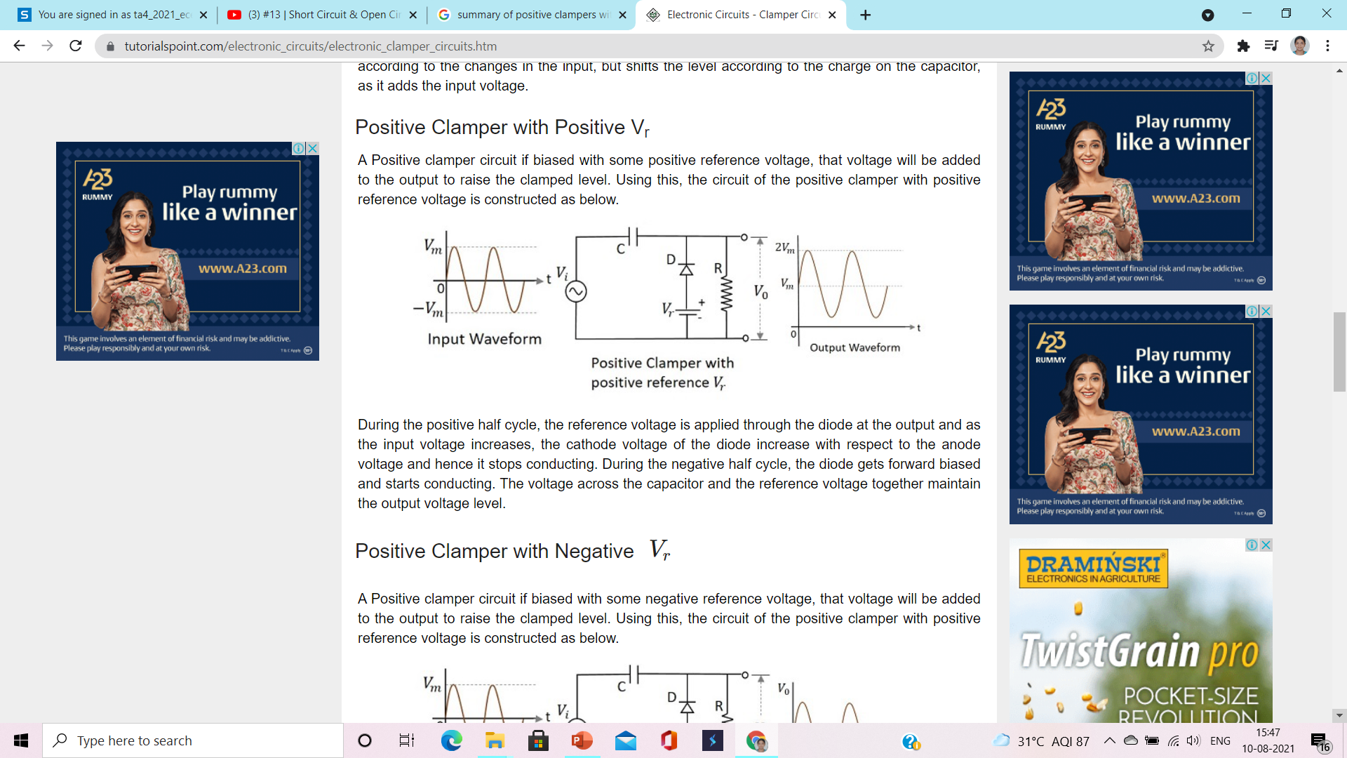

**3. Positive clamper with negative Vt**

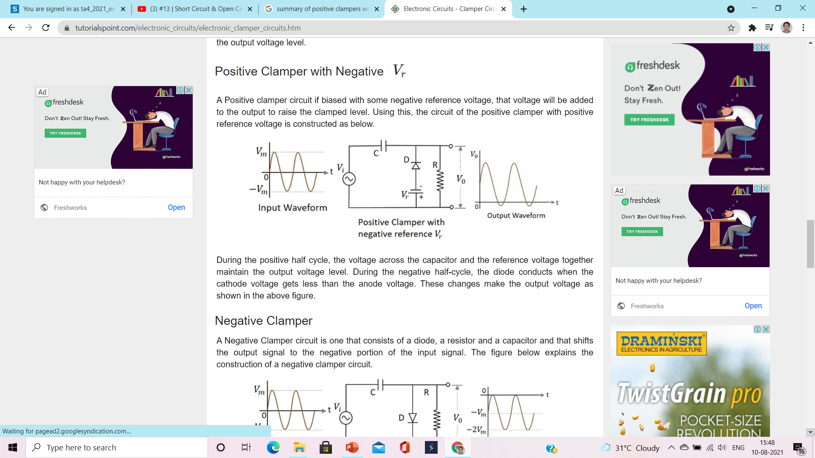

**4. Negative clamper**

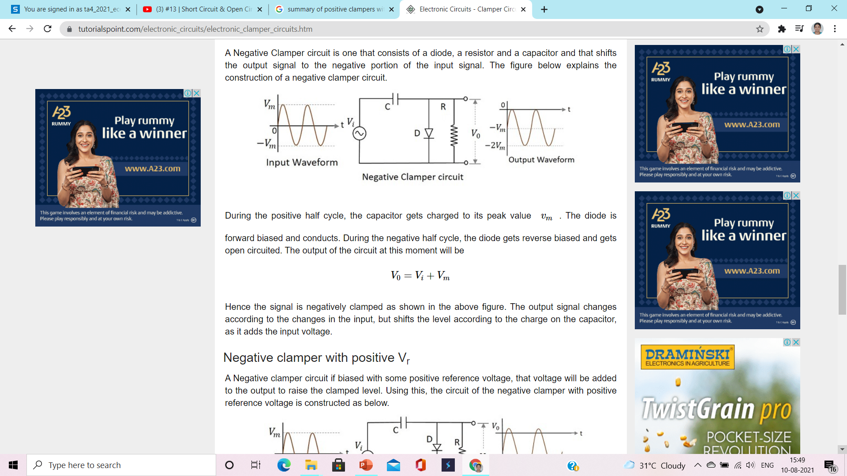

**5 Negative clamper with positive Vt**

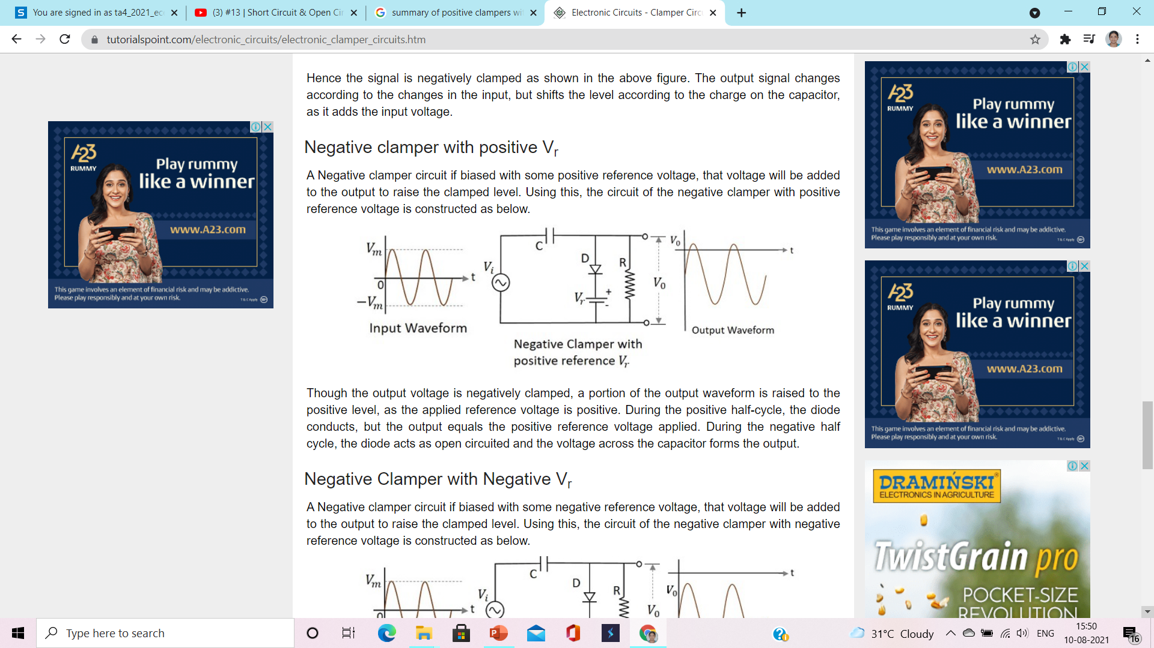

**6 Negative clamper with negative VT**

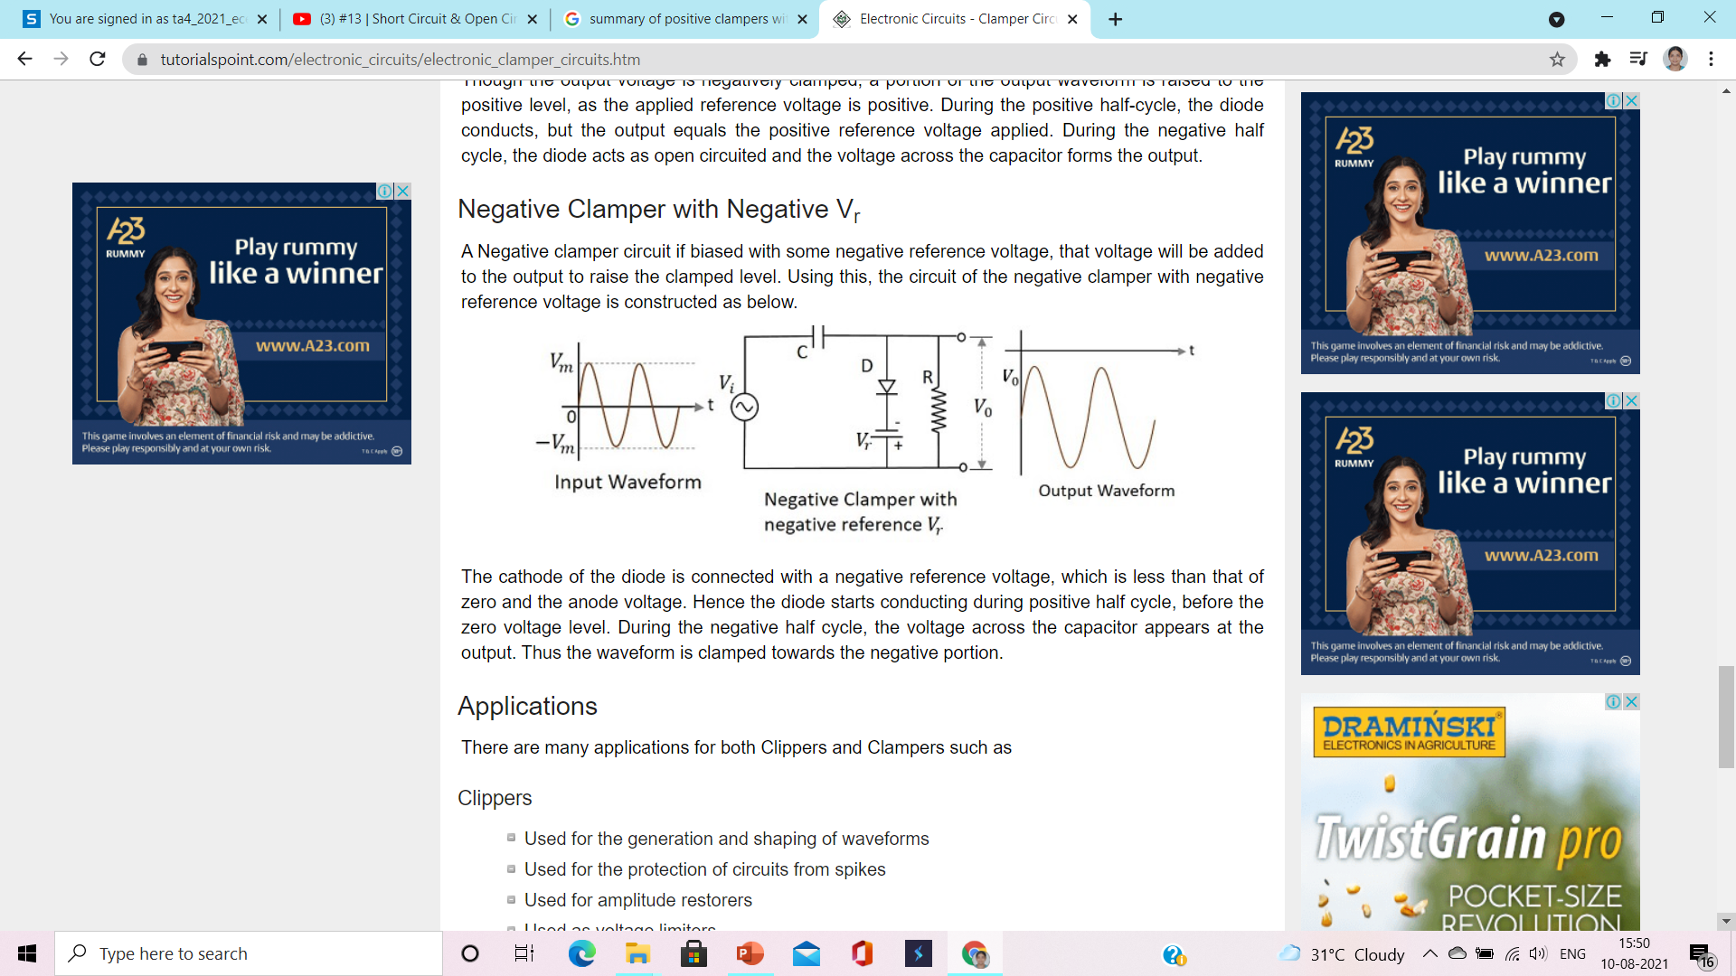

**1) positive clamper**

**Circuit/connection diagrams (fROM multisim)**

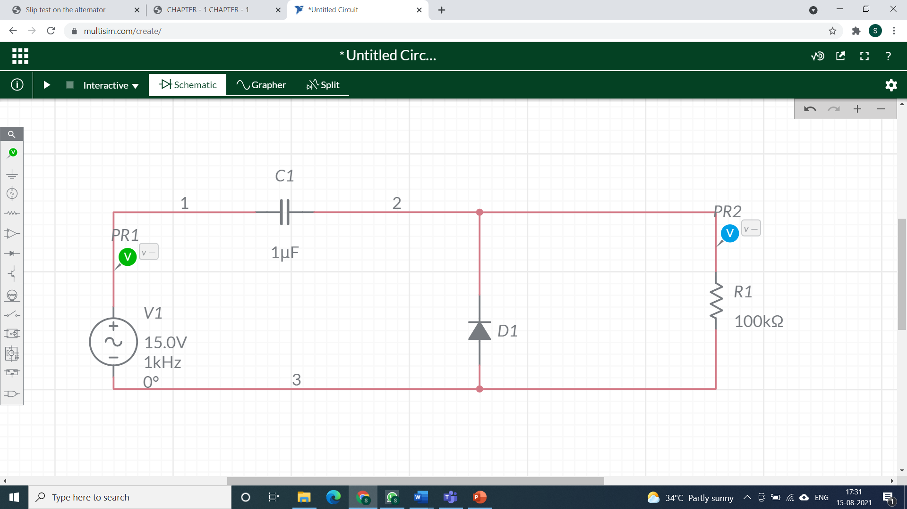

**waveforms (fROM multisim)**

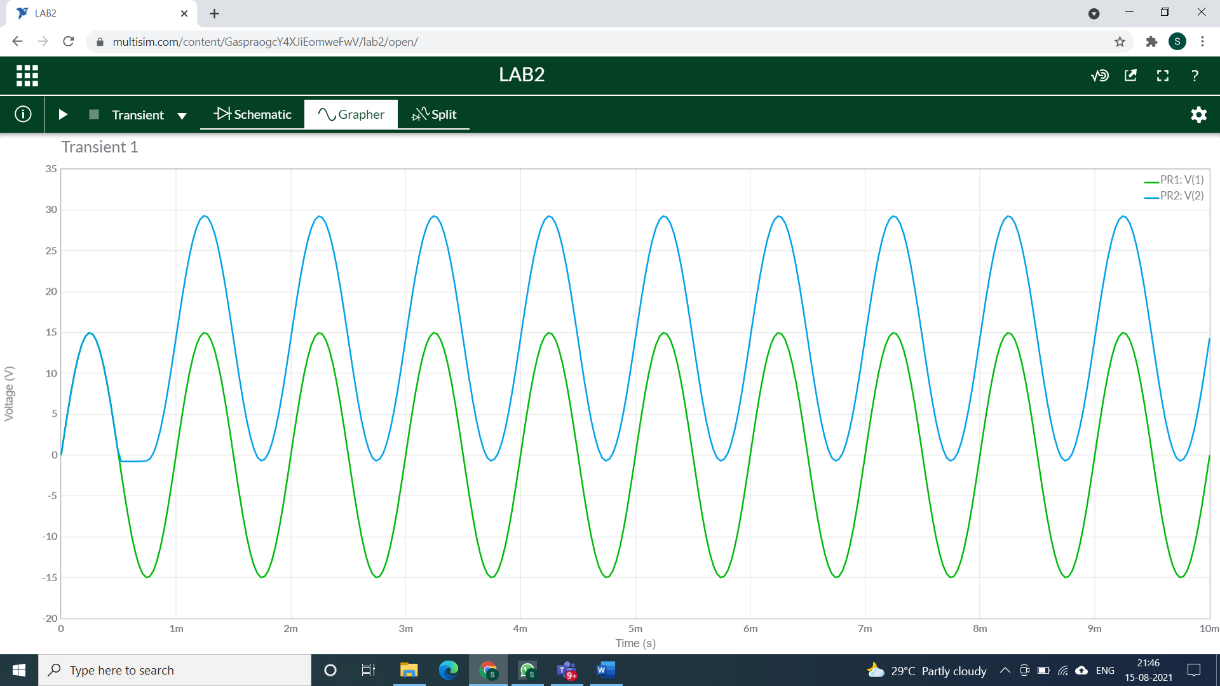

**Calculations:**

**L**et **Vc** be the voltage of capacitor:

**CASE 1:** For interval 0<t<T/2

Diode is reversed biased, so it will act like open circuit in ideal condition.

By applying Kirchhoff’s voltage law:

Vi + Vc - Vo = 0

Vo = Vi + Vi

Vo = 2Vi =30V

**CASE 2:** For interval T/2<t<T

Diode is forward biased, so it will act like short circuit in ideal condition.

By applying Kirchhoff’s voltage law:

-Vi + Vc - Vo = 0

Vc = 15V

**2) positive clamper circuit with positive reference**

**Circuit/connection diagrams (fROM multisim)**

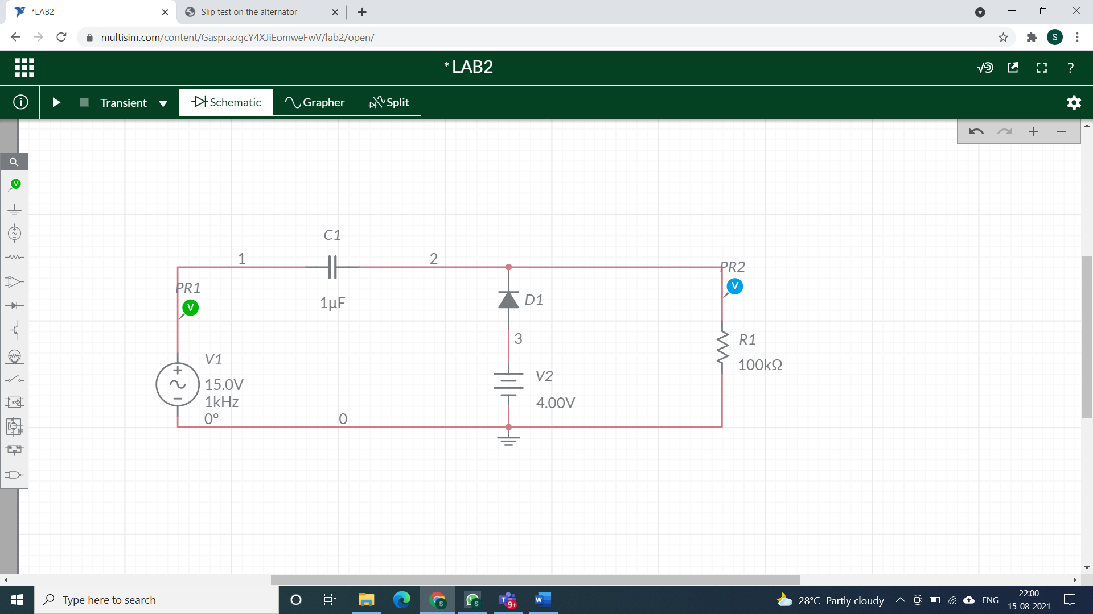

**waveforms (fROM multisim)**

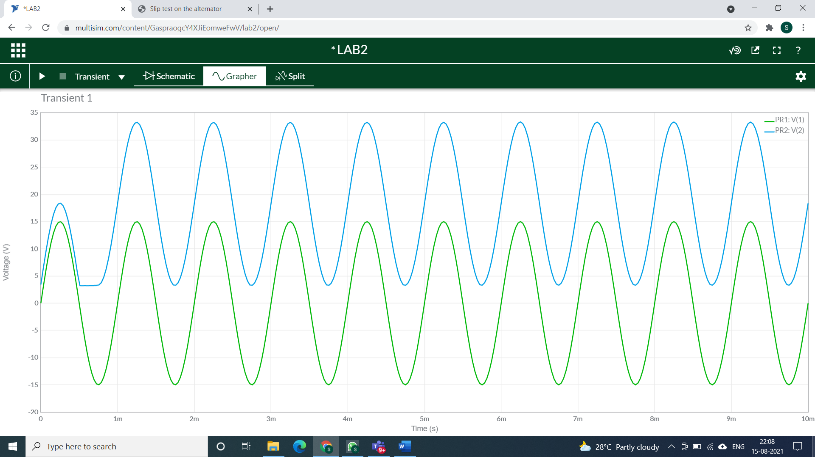

**CALCULATIONS**

**CASE 1:** For interval 0<t<T/2

Diode is reversed biased, so it will act like open circuit in ideal condition.

By applying Kirchhoff’s voltage law:

Vi + Vc - Vo = 0

Vo = Vc + Vi

= 15V + 19V = 34V

**CASE 2:** For interval T/2<t<T

Diode is forward biased, so it will act like short circuit in ideal condition.

Assume that capacitor will charge p instantaneously to a voltage level determined by the surrounding network. As diode is short circuited Vo = Vr = 4V

Applying KVL: -Vi + Vc - Vo = 0

Vc = 19V

**3) positive clamper circuit with NEGATive reference**

**Circuit/connection diagrams (fROM multisim)**

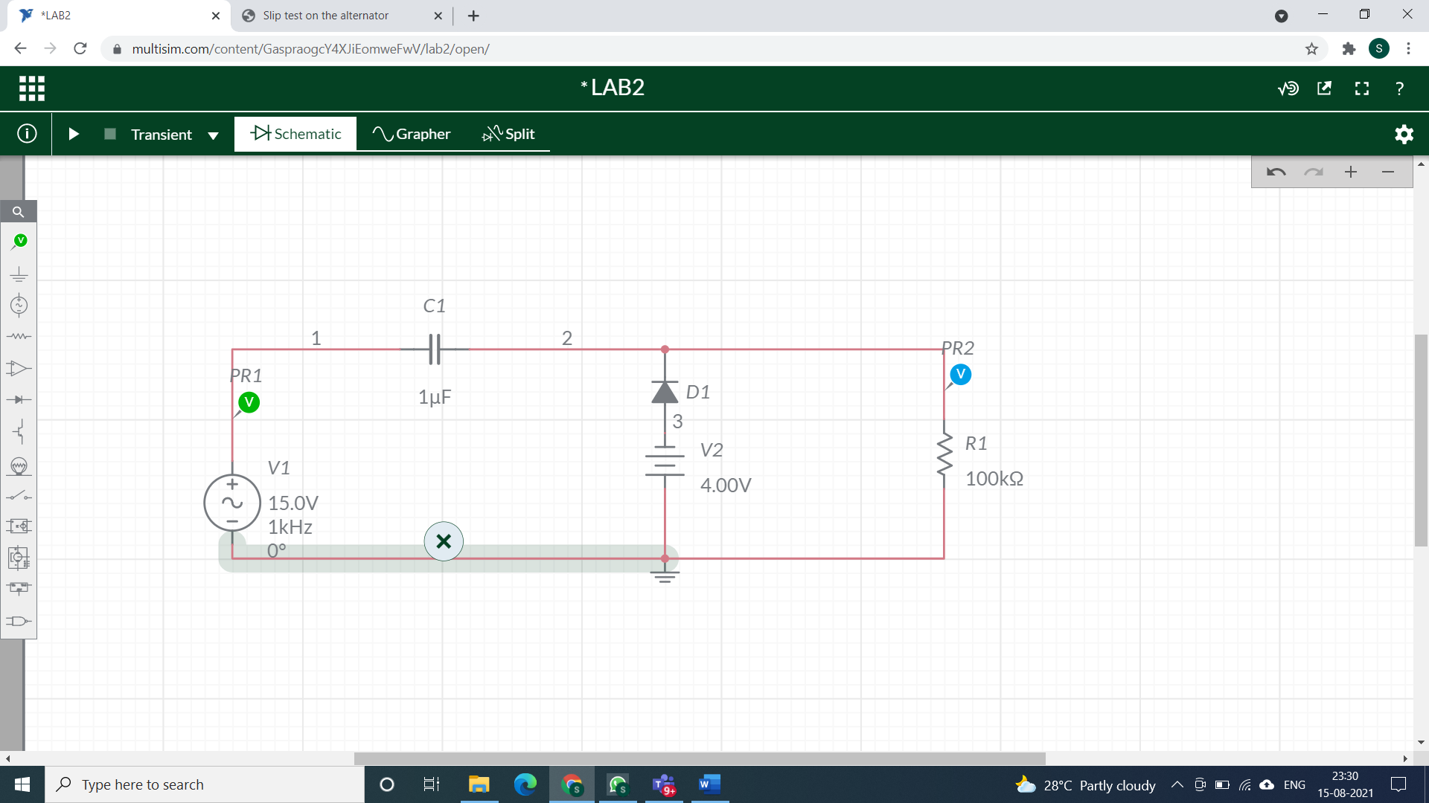

**waveforms (fROM multisim)**

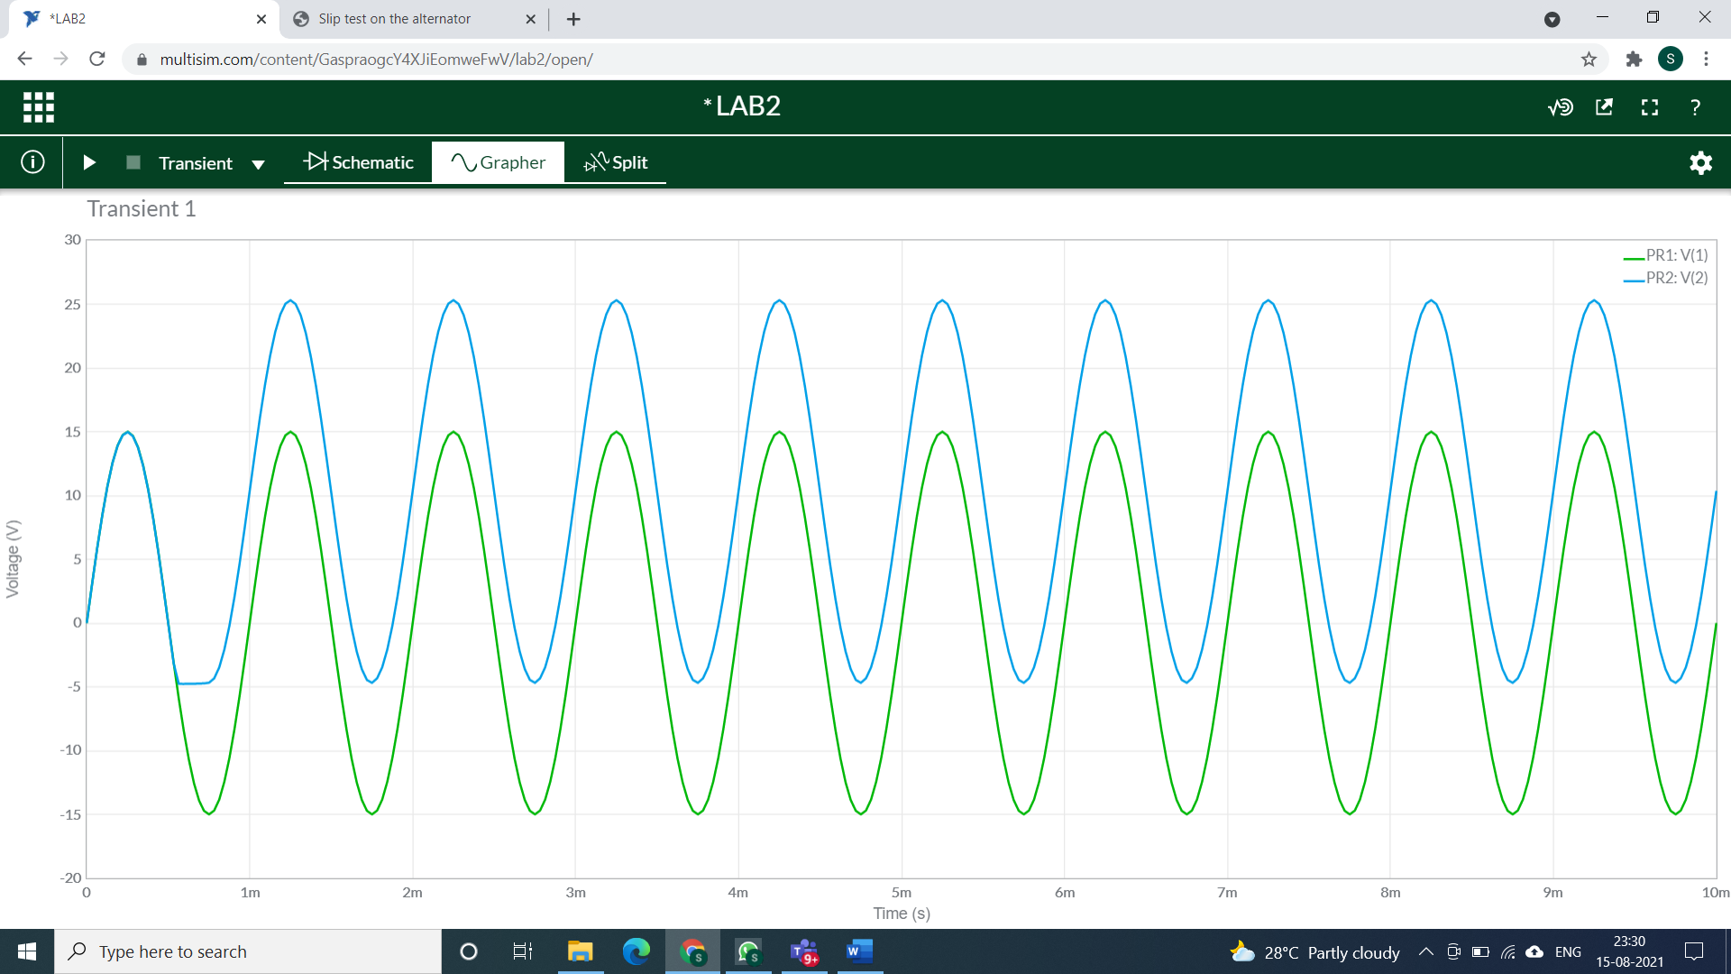

**Calculations:**

CASE 1: For interval 0<t<T/2

Diode is reversed biased so will act as open circuit.

Applying KVL:

Vi + Vc – Vo = 0

Vo = 15V + 11V = 26V

CASE 2: For interval 0<t<T/2

Diode is forward biased.

Assume that capacitor will charge p instantaneously to a voltage level determined by the surrounding network. As diode is short circuited Vo = Vr = -4V

Applying KVL: -Vi + Vc - Vo = 0

Vc=11V

**4) negative clamper**

**Circuit/connection diagrams (fROM multisim)**

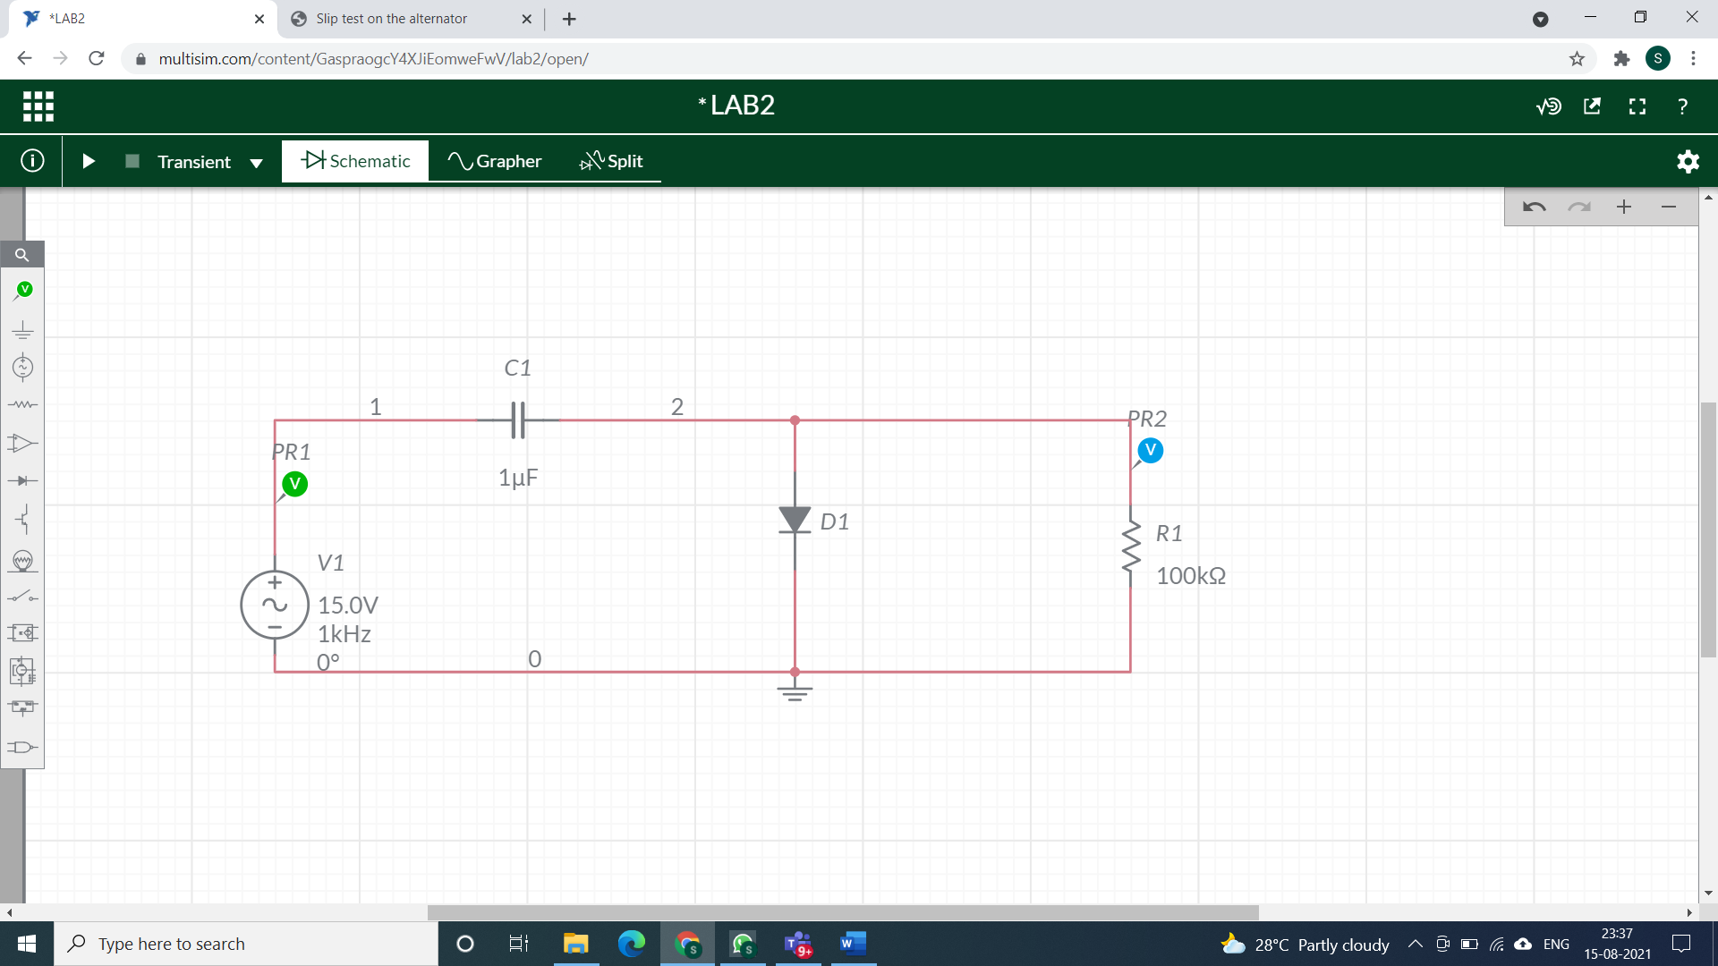

**waveforms (fROM multisim)**

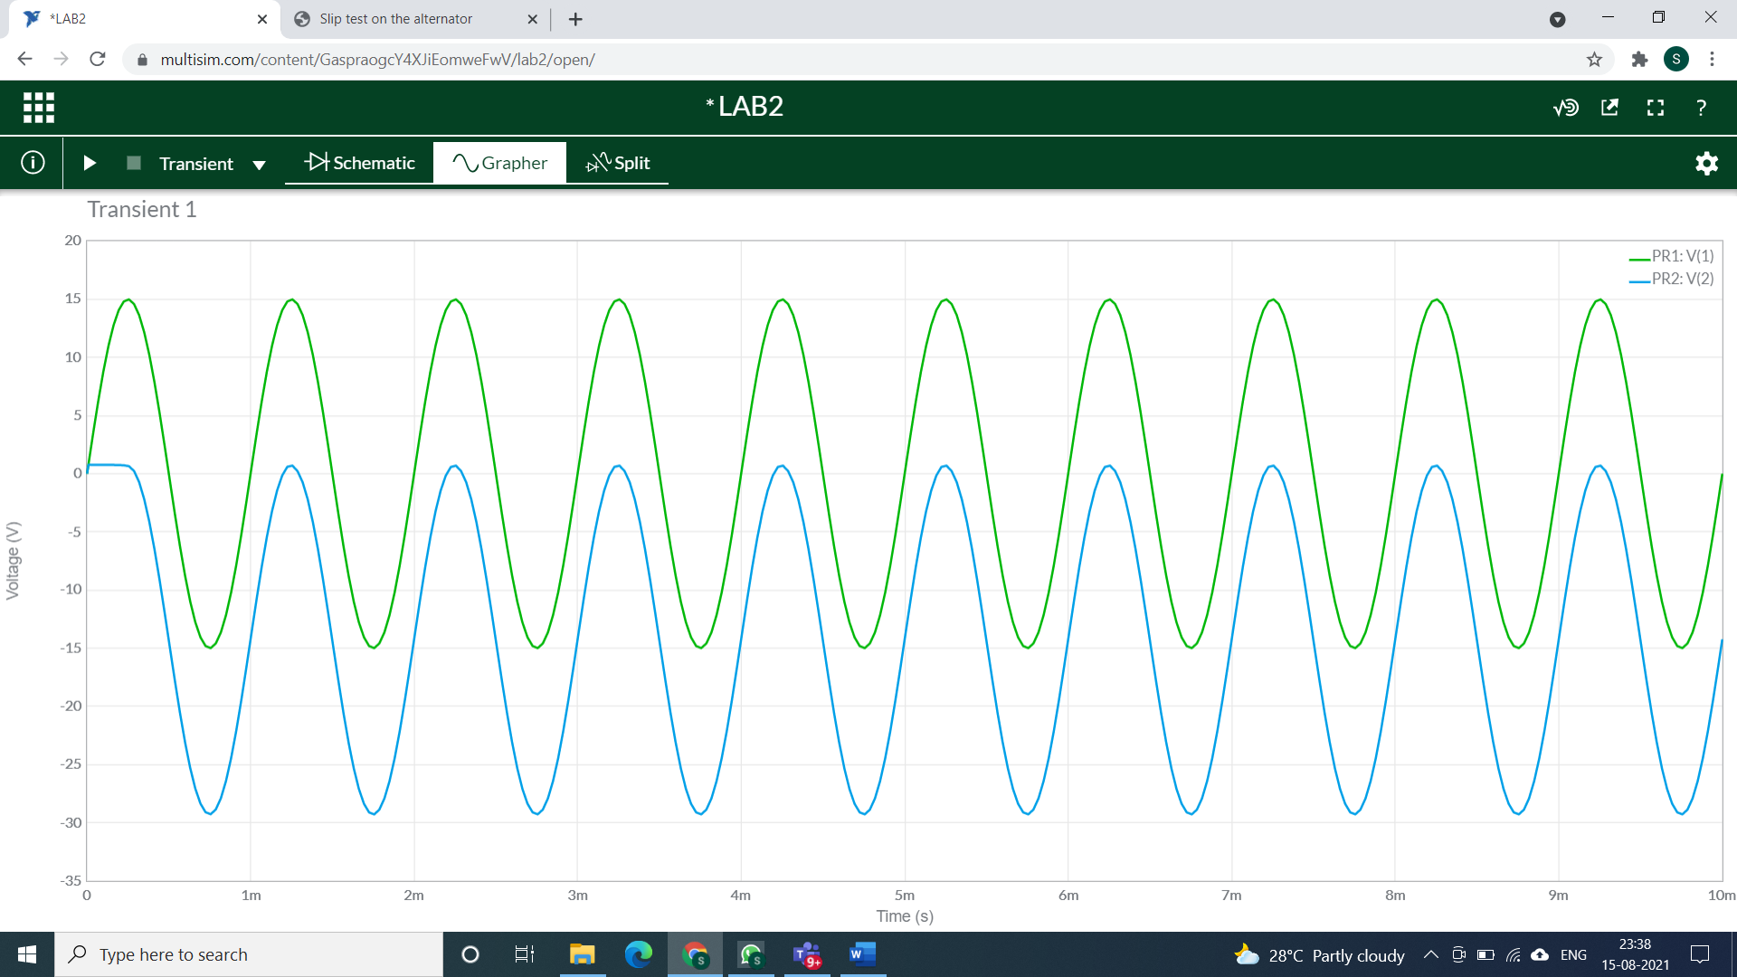

**Calculations:**

Case-1: For interval 0<t<T

Assume that capacitor will charge p instantaneously to a voltage level determined by the surrounding network. As diode is short circuited Vo = 0

Voltage across capacitor Vc : Applying KVL: Vi - Vc - Vo = 0

Vc = -15V

Case-2) For interval T/2<t

Diode is reverse bias.

As diode is open circuited

Applying KVL : -Vi - Vc - Vo = 0

Vo = -Vi – Vi

Vo = -2Vi =-30V

**5) NEGATIVE clamper circuit with positive reference**

**Circuit/connection diagrams (fROM multisim)**

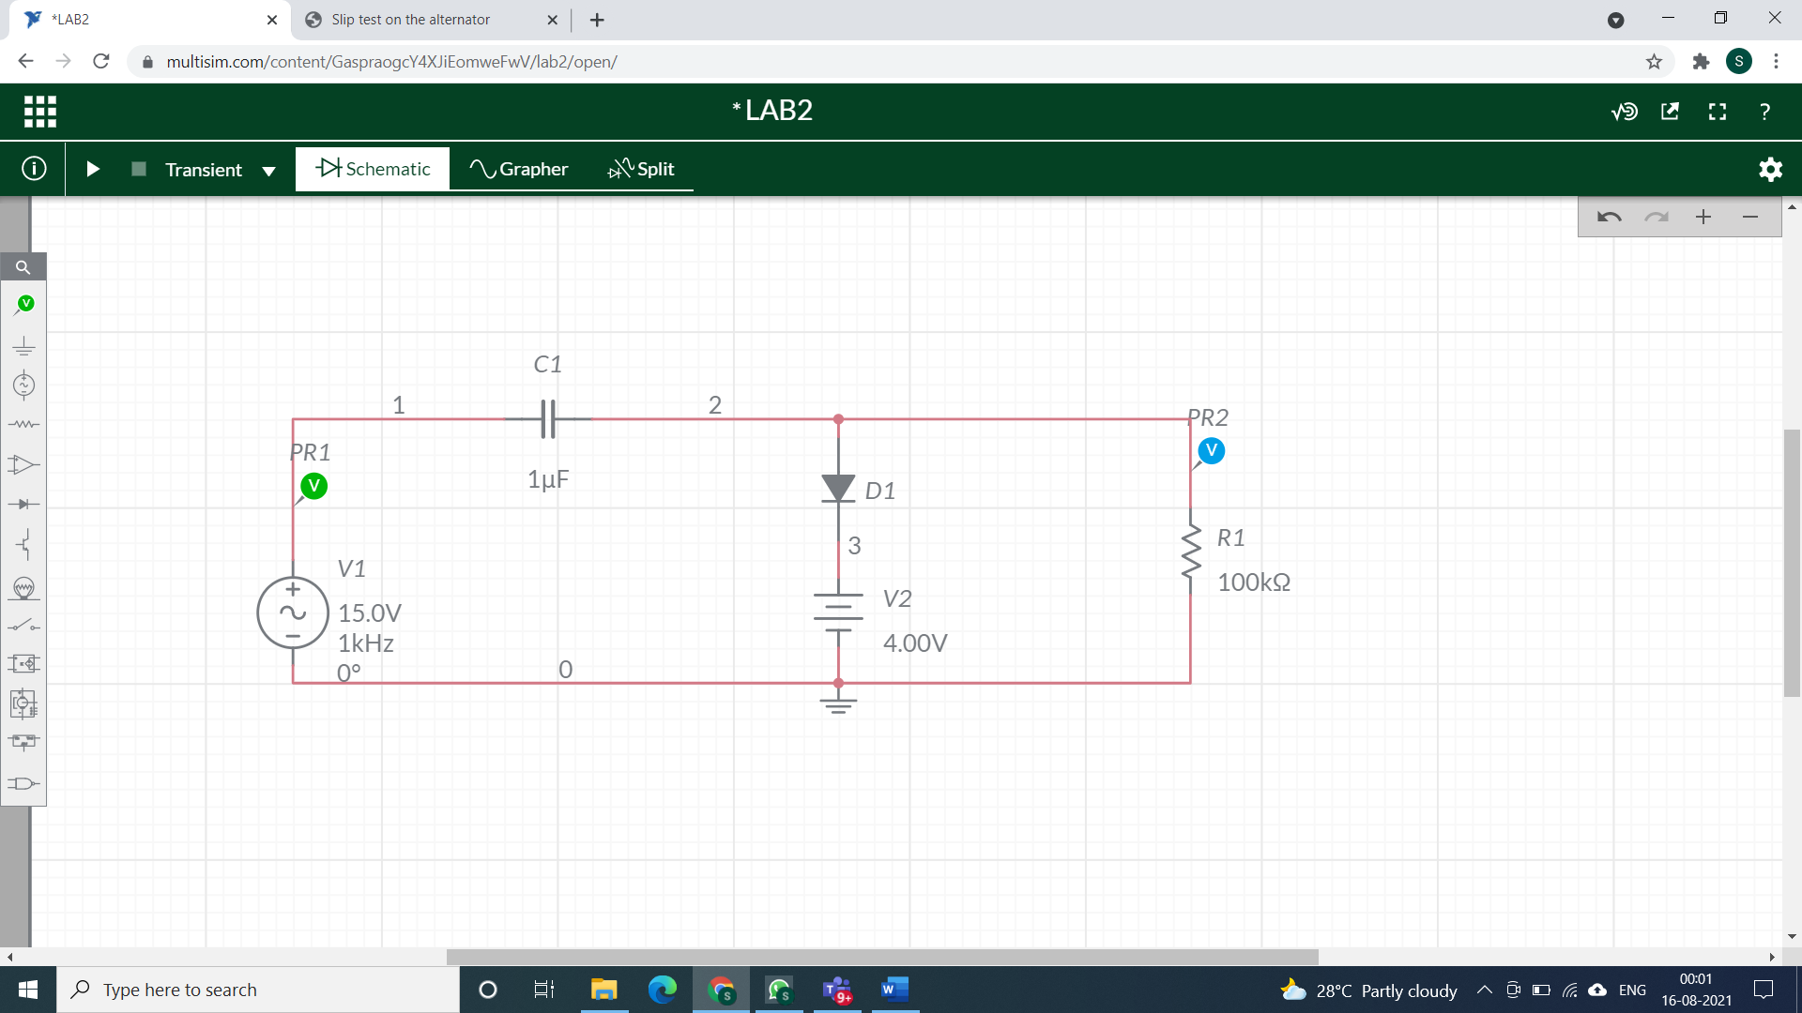

**waveforms (fROM multisim)**

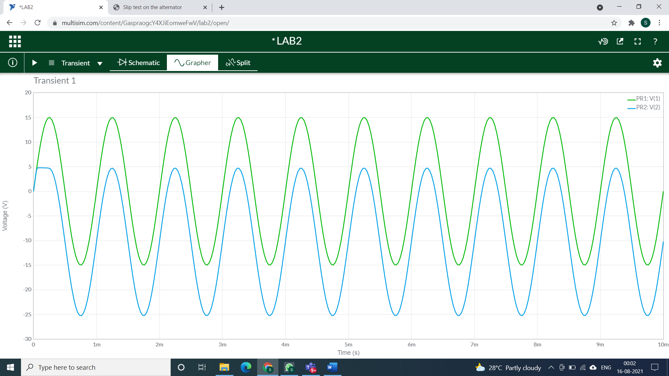

**Calculations:**

Case-1) For interval 0<t<T/2

Diode is forward bias. Assume that capacitor will charge p instantaneously to a voltage level determined by the surrounding network.

As diode is short circuited Vo = Vr = 4V

Voltage across capacitor Vc :

Applying KVL: Vi - Vc - Vo = 0

Vc = 11V

Case2: For interval T/2<t<T

Diode is reversed biased.

As diode is open circuited.

Applying KVL: Vi – Vc – Vo = 0

Vo = -Vc – Vi

Vo = -11V -15V = -26V

**6) NEGATIVE clamper circuit with negative reference**

**Circuit/connection diagrams (fROM multisim)**

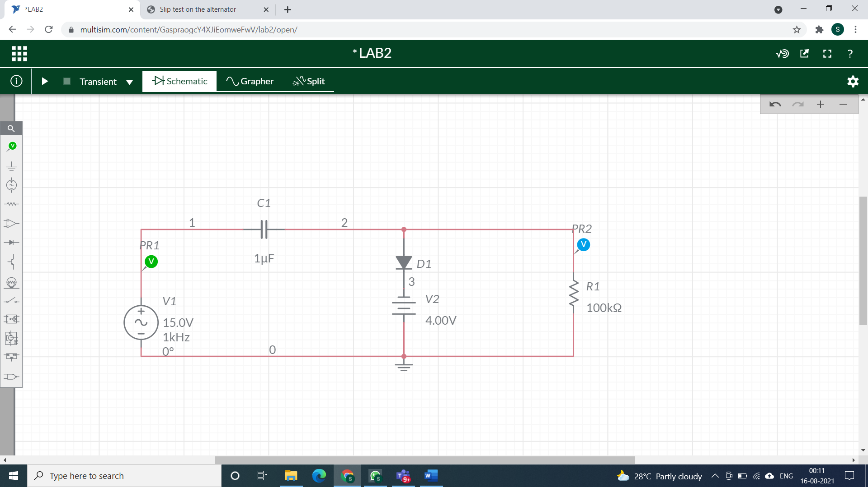

**waveforms (fROM multisim)**

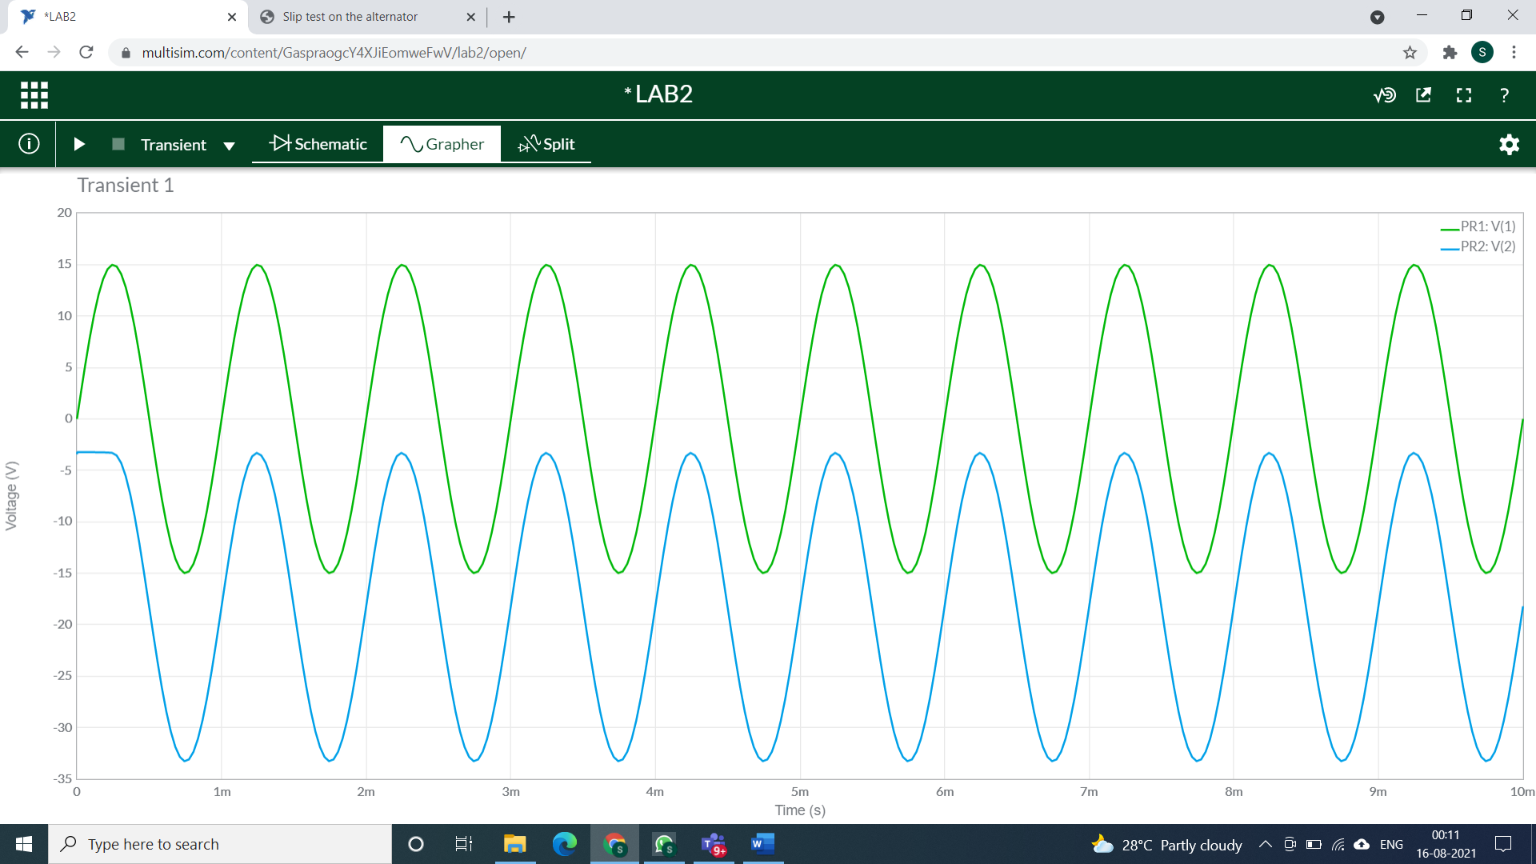

**Calculations:**

Case-1) For interval 0<t<T/2

Diode is forward bias. Assume that capacitor will charge p instantaneously to a voltage level determined by the surrounding network

As diode is short circuited Vo = Vr = -4V

Voltage across capacitor Vc :

Applying KVL: Vi - Vc - Vo = 0

Vc = 19V

Case-2) For interval T/2<t<T:

Diode is reverse bias.

As diode is open circuited

Applying KVL : -Vi - Vc - Vo = 0

Vo = -Vc – Vi

Vo = -19V - 15V = -34V

**Conclusions**

Here, the practical and theoretical characteristics of various negative and positive clamper (with and without bias) are same. Hence verified.

**Assignment**

**question 1:**

**Circuit/connection diagrams (fROM multisim)**

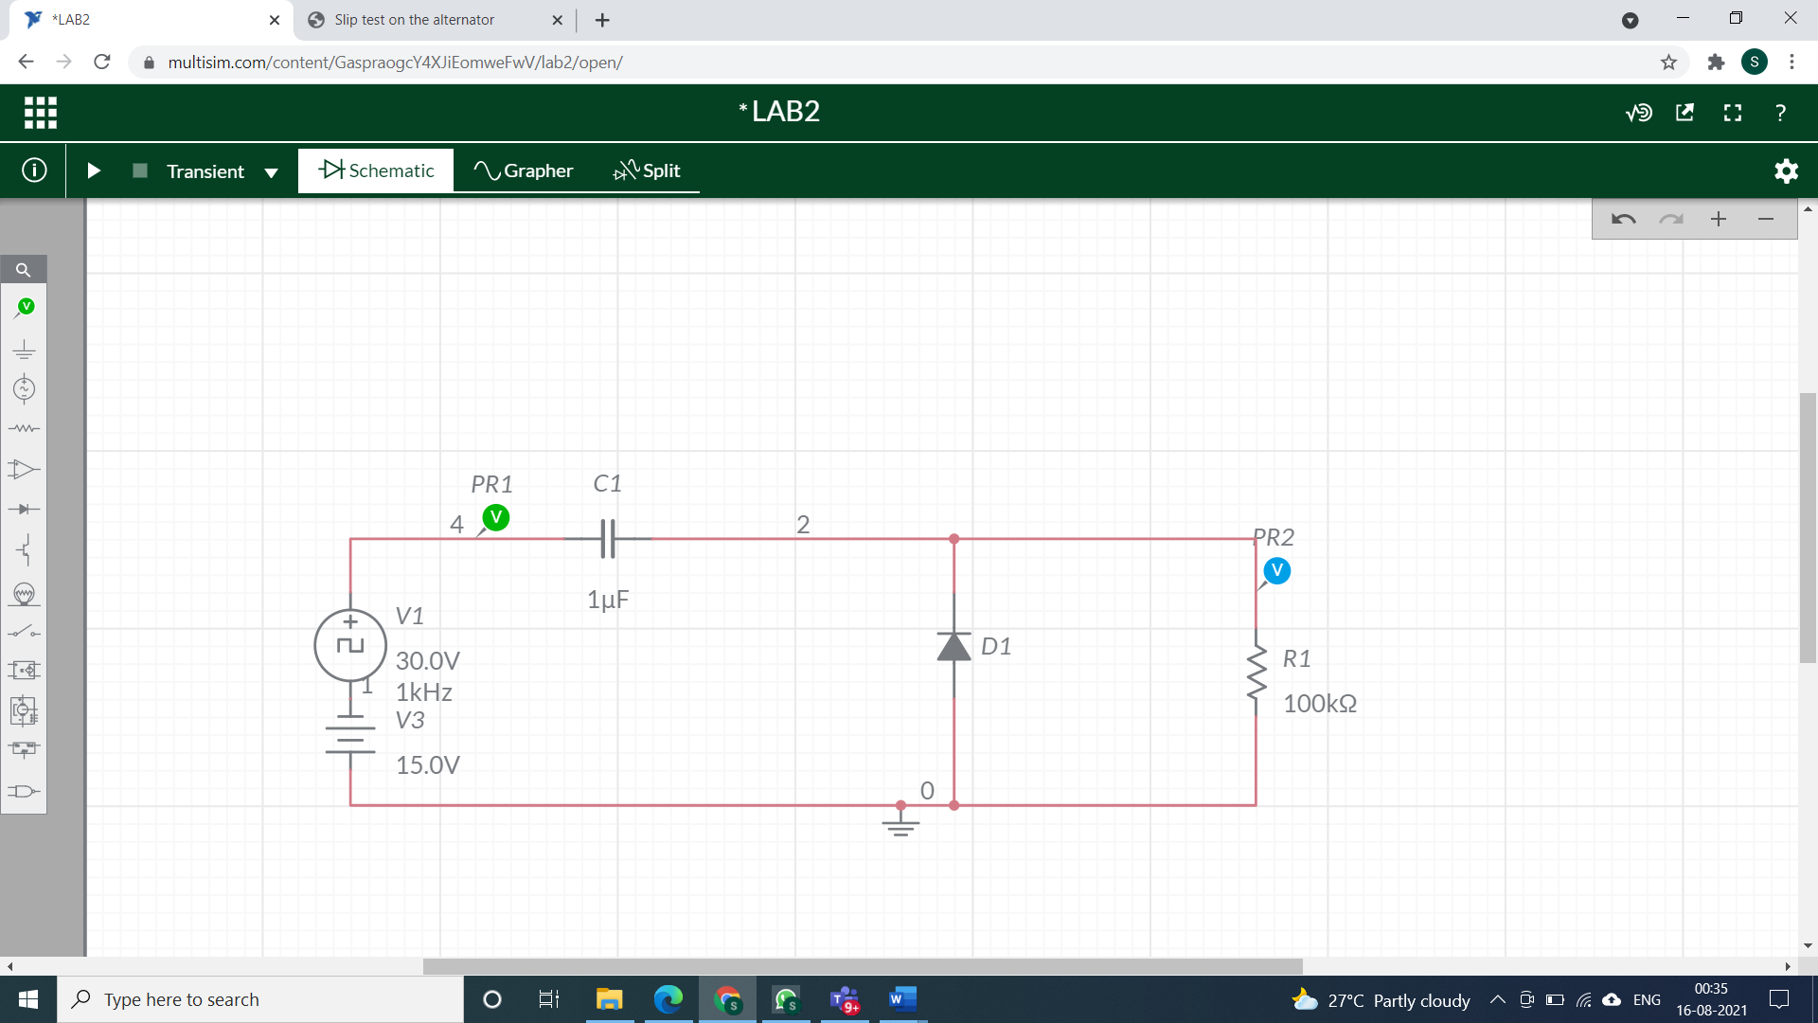

**waveforms (fROM multisim)**

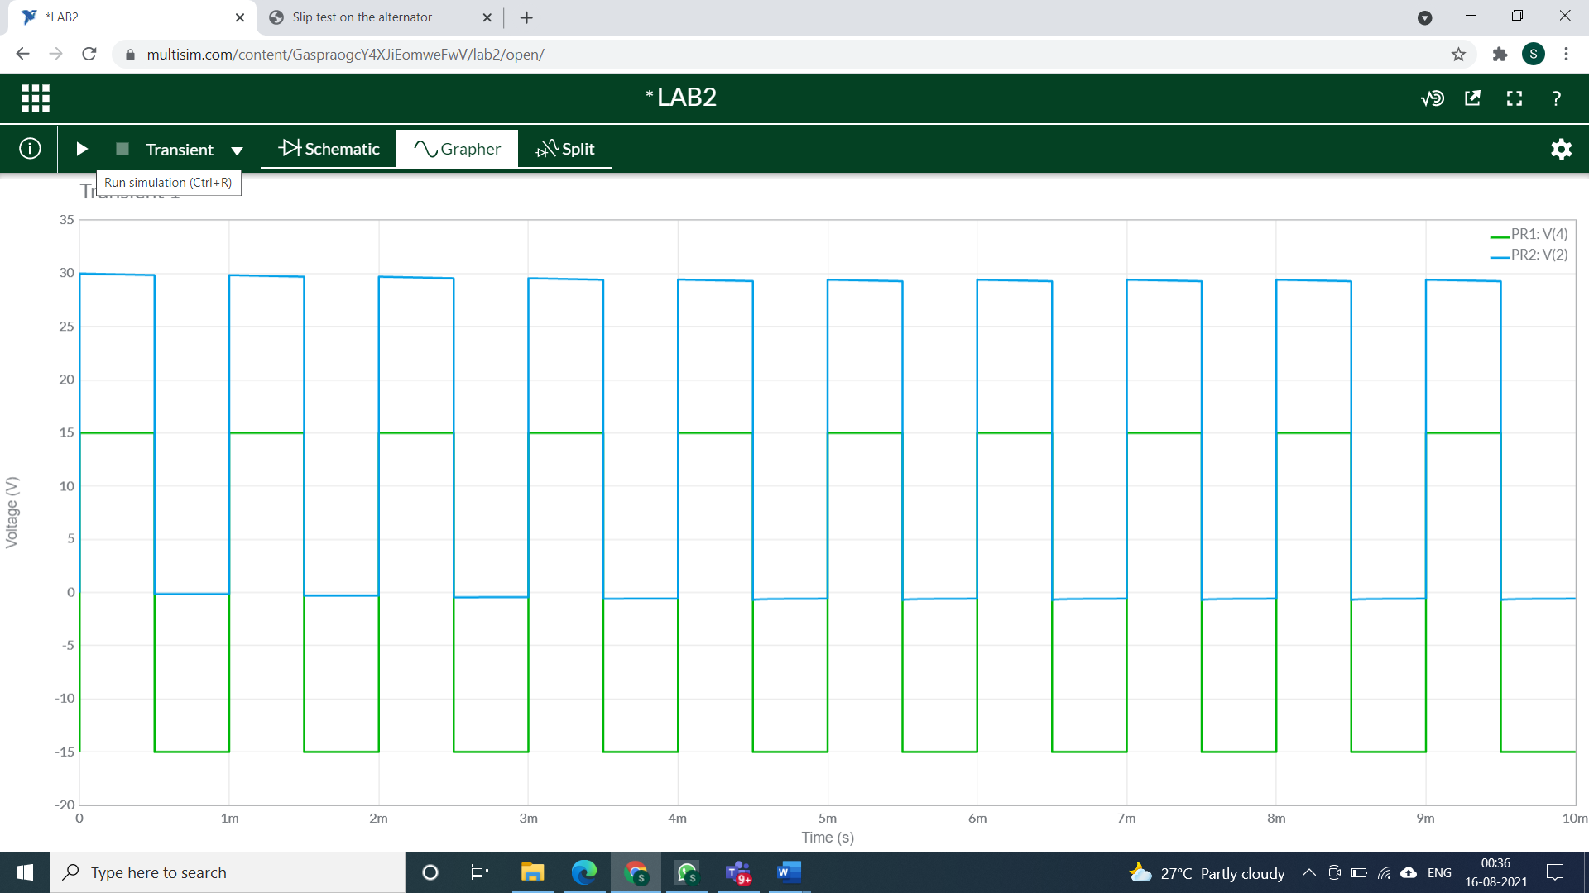

**question 2:**

**Circuit/connection diagrams (fROM multisim)**

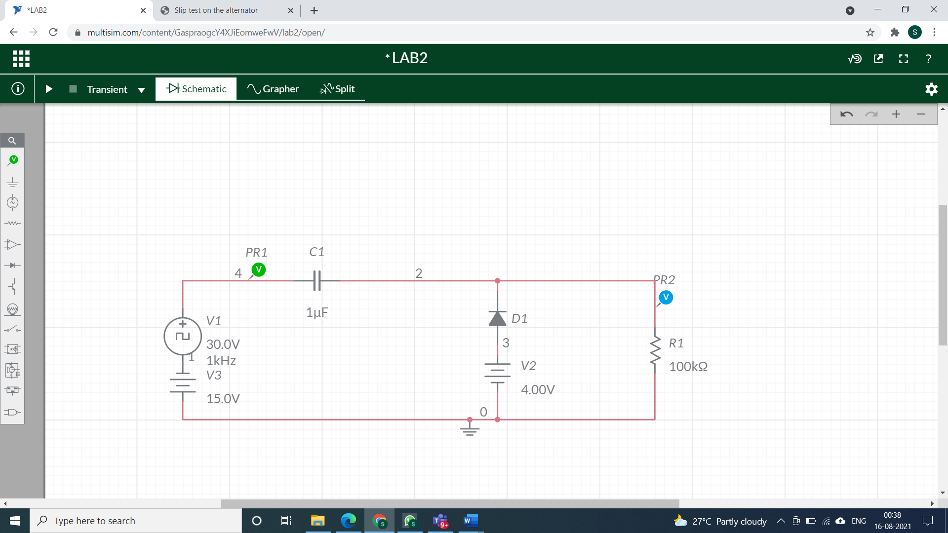

**waveforms (fROM multisim)**

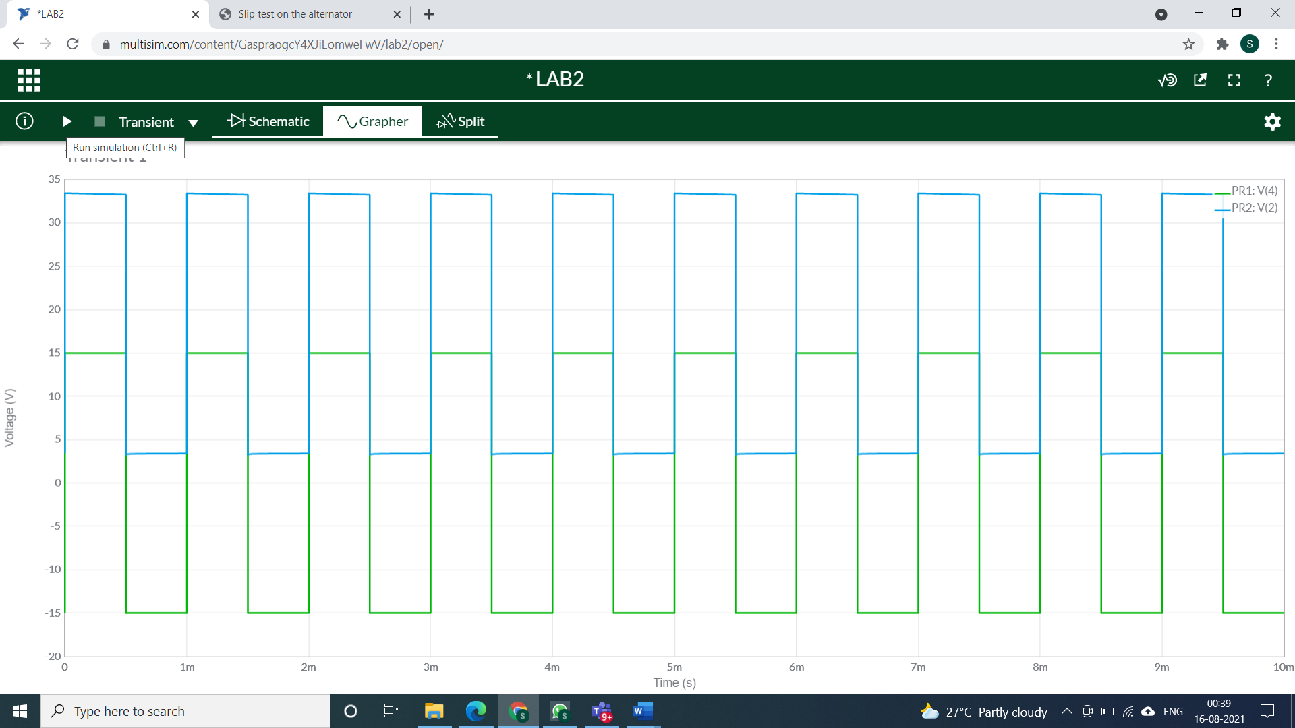

**question 3:**

**Circuit/connection diagrams (fROM multisim)**

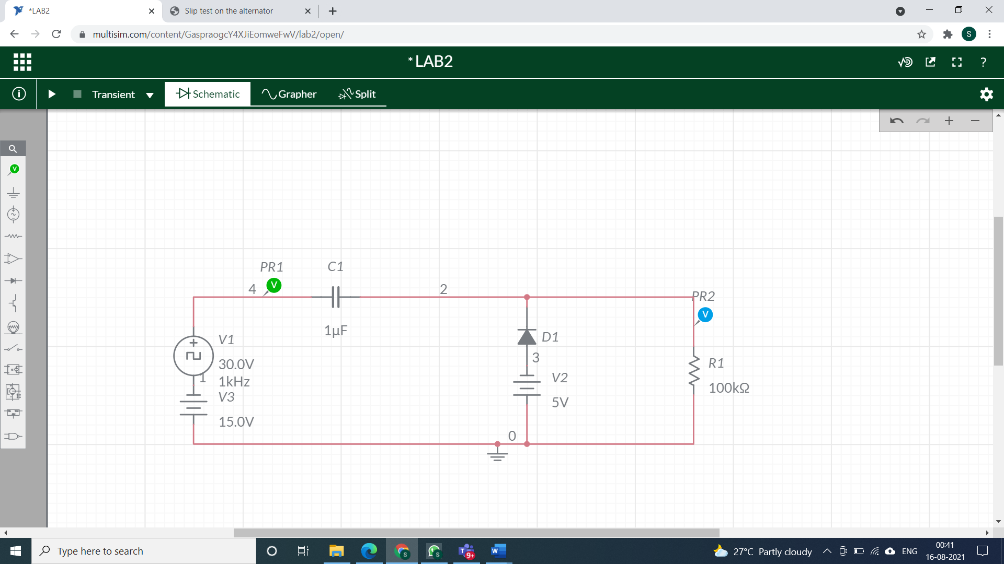

**waveforms (fROM multisim)**

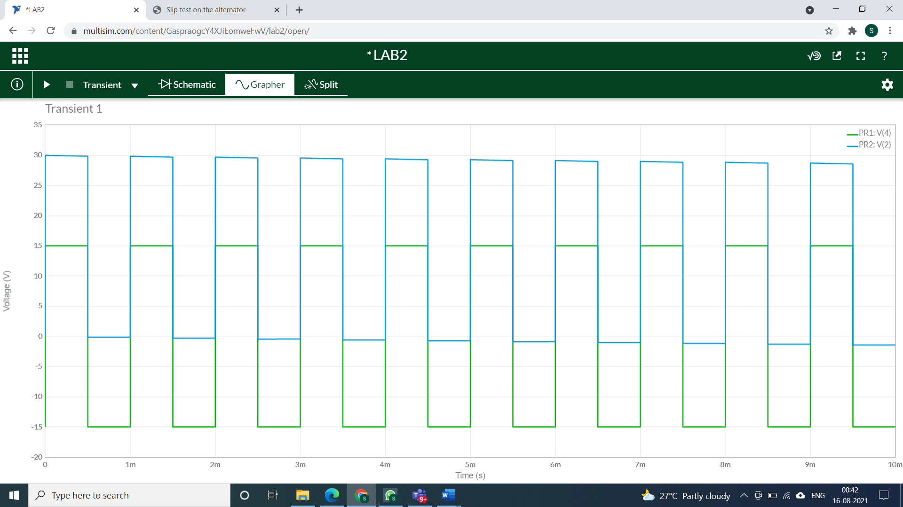

**question 4:**

**Circuit/connection diagrams (fROM multisim)**

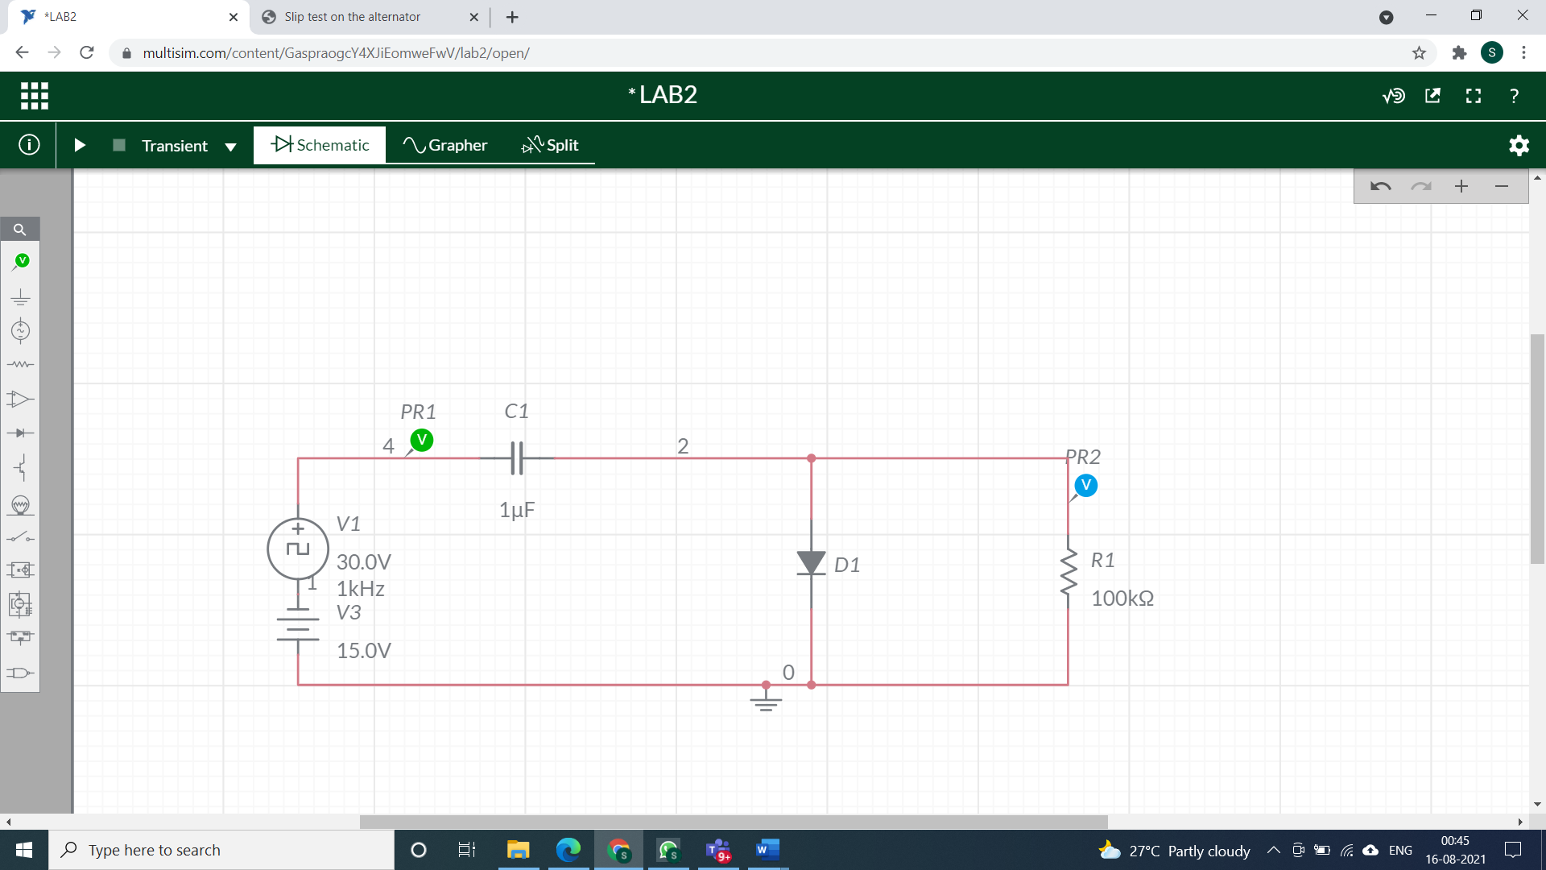

**waveforms (fROM multisim)**

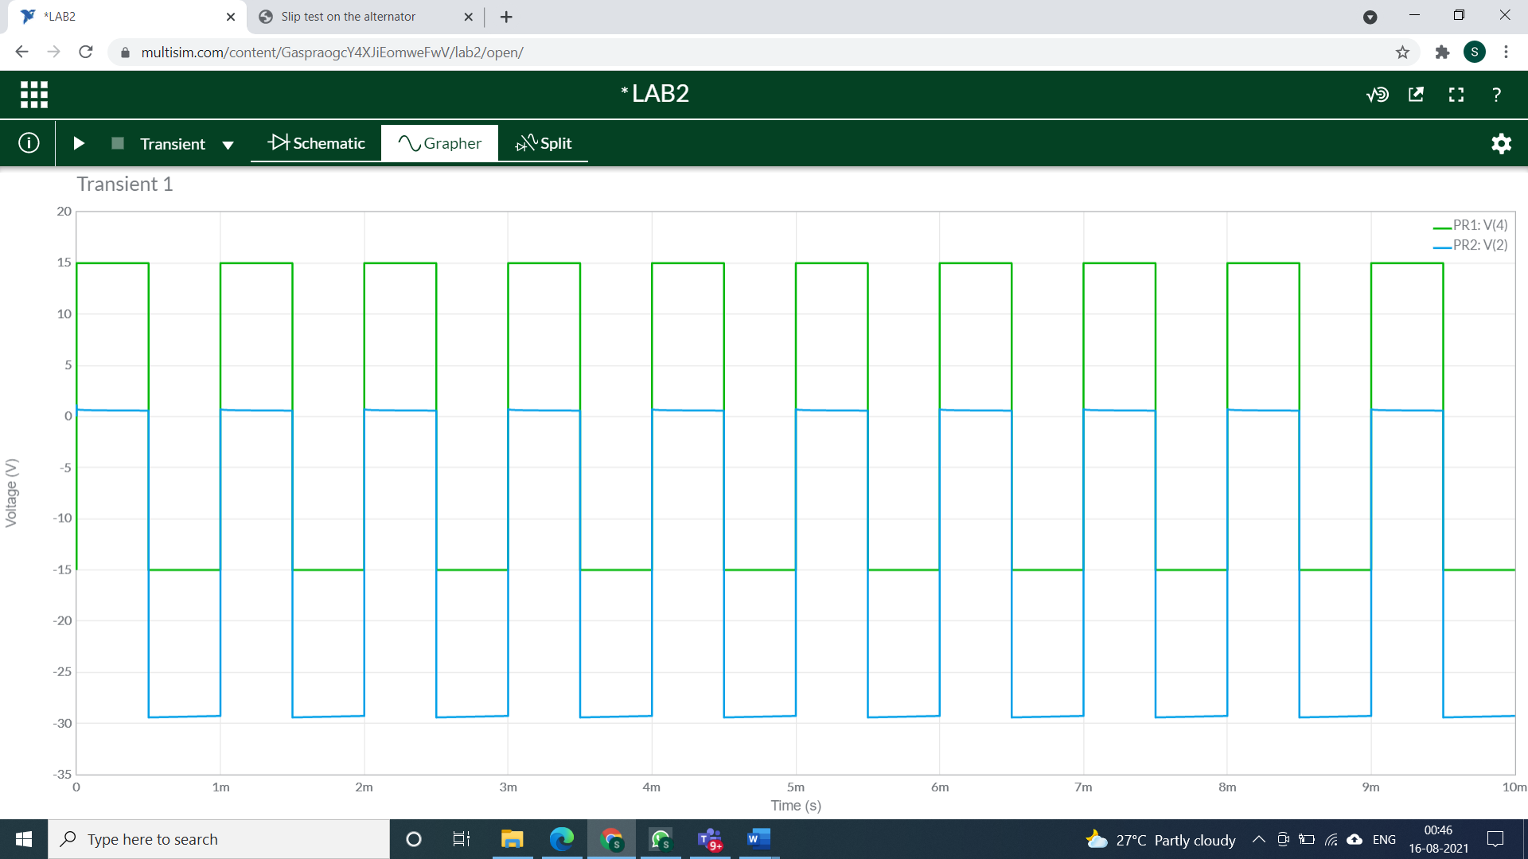

**question 5:**

**Circuit/connection diagrams (fROM multisim)**

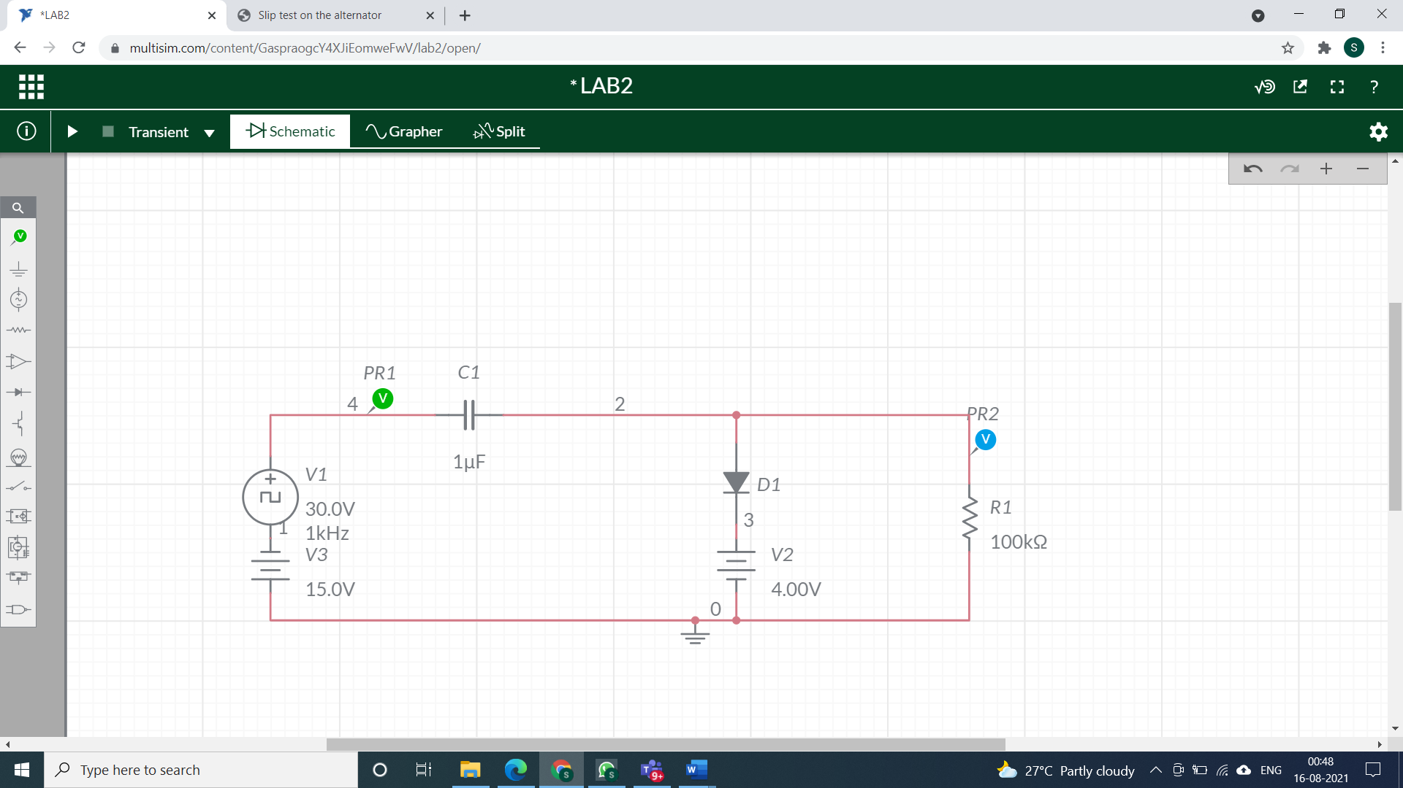

**waveforms (fROM multisim)**

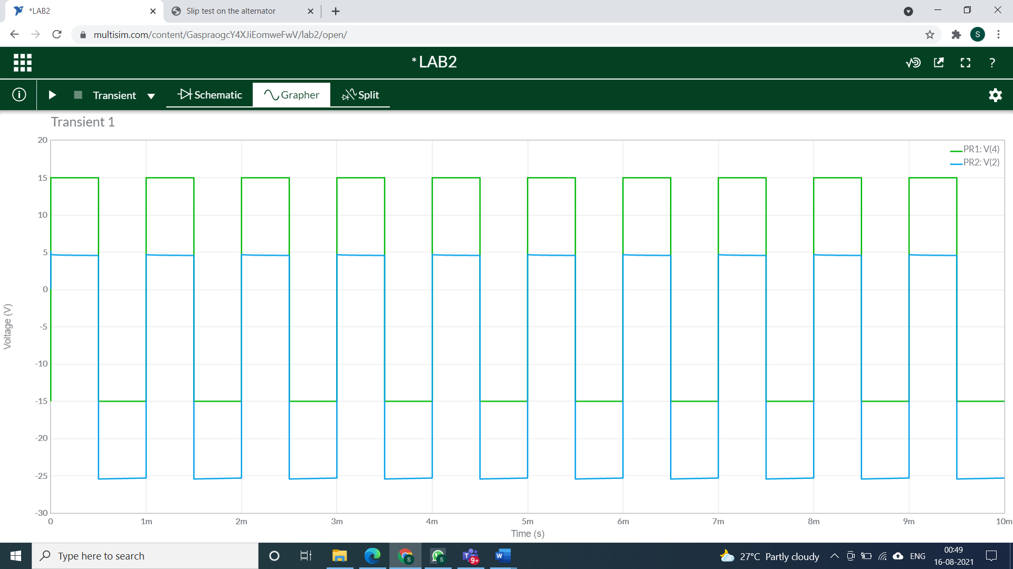

**question 6:**

**Circuit/connection diagrams (fROM multisim)**

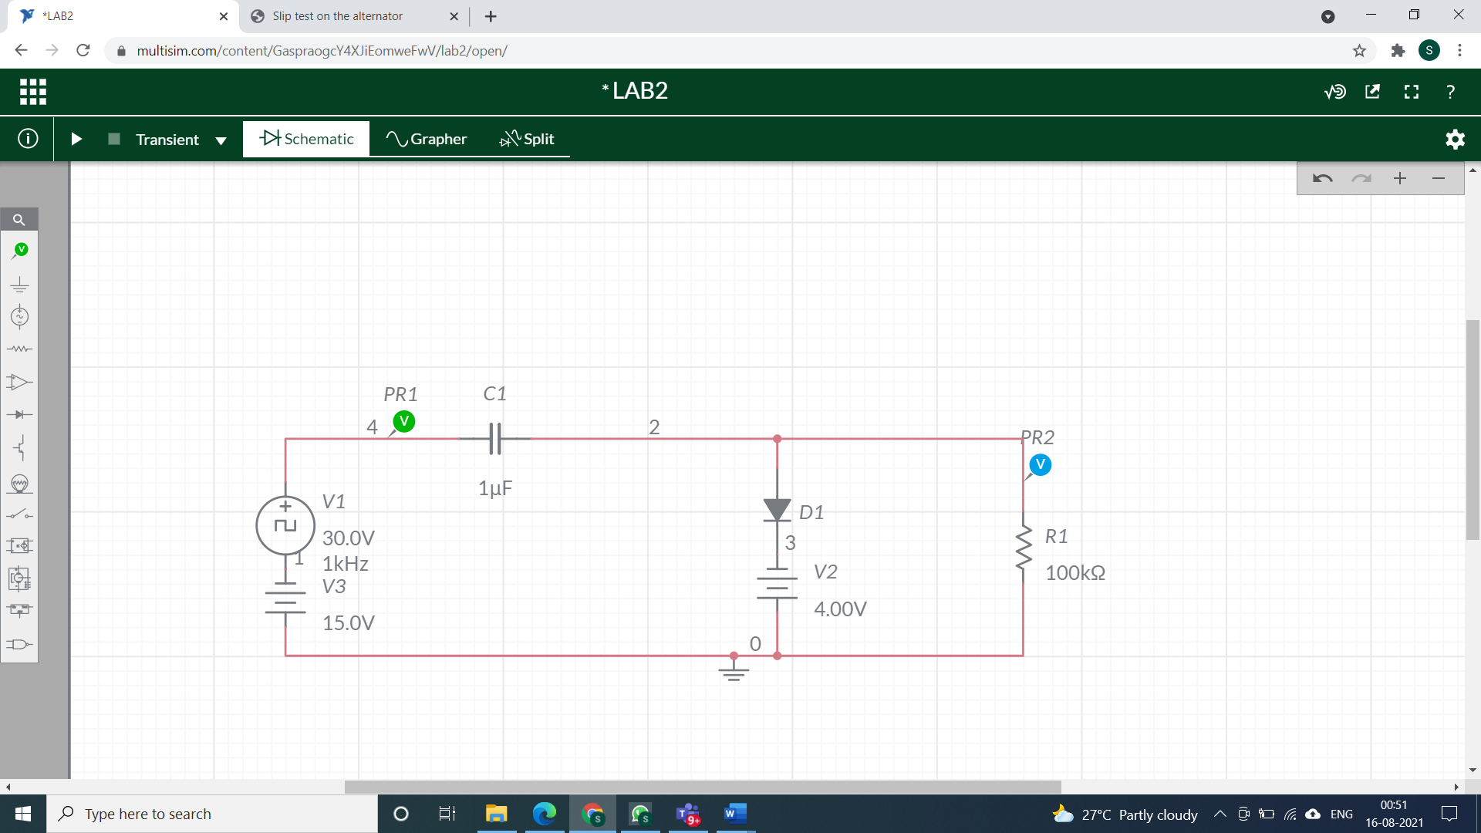

**waveforms (fROM multisim)**

